**Linux Command**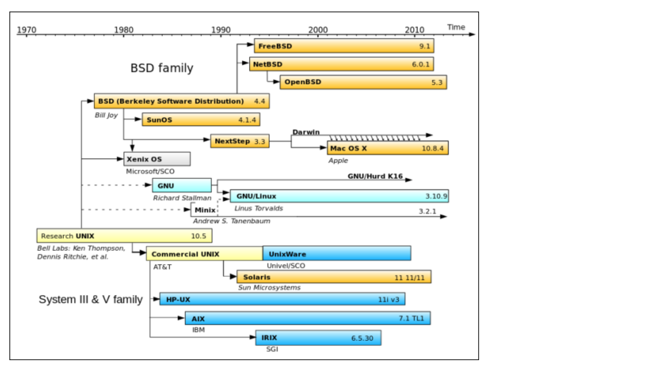

**Create a file**

Touch file

“>” file

cat > file (to exit control+D)- at the time create file start writing)

cat >>oldFile(exit control+D)

vi file (write text (exit :wd)) <https://www.cs.colostate.edu/helpdocs/vi.html>

echo “write text” >file (crate a new file and write it)

echo “write text” >>OldFile (write in old file)

date >>oldfile(write date)

nano Oldfile(write like in text pad”don’t put > or >>)

cat or more file(see file)

1. **>** is output redirection symbol.
2. **>>** is append output redirection symbol.

Install application

sudo apt-get install emacs

sudo apt-get update

to check if install

apt-cache policy <package-name>

MAN command

G – move to the bottom of the page

g- move to the top of the page

q- quit

enter- moves down

* all the variable are upper case
* variables are always upper case starting with echo, eg. Echo $VAR_NAME
* PATH is environmental variable search the path, controls the command search path, contains a list of directories.

$ regular user

search with the man pages which command to use

man –k SEARCH_TERM

if need help - -help or –h

Listing files by type

* (ls –F) to reveal file type.
  + / Directory
  + @ Link
  + * Executable
* (ls –t or ls -lt) list by time --- ‘l’ for long list
* (ls –r or ls -lr) reverse order
* (ls –latr) long listing including all files reverse sorted by time

LIST FILE RECURSIVELY

* (ls –R) list files recursively
* (tree – d) list directories only
* (tree –c) colorize output
* (ls –d) list directory name, not contents.
* (ls - -color) colorize the output

WORKING WITH SPACES IN THE NAMES OF THE FILE

* Encapsulate the entire file name in a quotes, (eg. Ram file – “Ramfile”)

Vi Editor

vi [file] Edit file

vi [file] same as vi, but more future – default in most linux

view [file] use to only view but not modified

NAVIGATION

h left

j up

k down

l right

w right one word

b left one word

^ Go to the beginning of the line

$ go to the end of the line

INSERT MODE

i – insert at the cursor position

I insert at the beginning of the line

a Append after the cursor position

A Append at the end of the line

LINE MODE  
 :w writes(saves) the file

:w ! forces the file to be saved

:q Quit

:q ! Quit without saving changes

:wq ! write and quit

:x Same as :wq

:n Position the cursor at line n

:$ position the cursor on the last line

:set nu Turn on line numbering

:set nonu Turn off line numbering

:help [subcommand] Get help

mode key

command Esc

Insert i | a A

line :

REPEATING COMMAND

5k Move up a line 5 times

80i<text><Esc> insert <test> 80 times

80i_<Esc> insert 80 “_” characters

Deleting Text

x Delete a character

dw Delete a word

dd Delete a line

D Delete from the current Position

Changing Text

r Replace the current character

cw Change the current word

cc change the current line

c$ change the text from the current position

C same as c$

~ Reverse the case of the character

Copying and pasting

yy Yank(copy) the current line

y <position> Yank the <position>

p Paste the most recent deleted or yanked text

Undo/Redo

u Undo

ctrl-R Redo

Searching

/<pattern> Start a forward search

?<pattern> Start a reverse search

TO KNOW THE MODE  
umask -S

Emacs has its own terminology for these concepts:

|  |  |  |  |
| --- | --- | --- | --- |
| **Common Name** | **Common Key** | **Emacs Name** | **Emacs Key** |
| Cut | C-x | Kill | C-w |
| Copy | C-c | Kill-ring-save | M-w |
| Paste | C-v | Yank | C-y |
| — | — | Yank next | M-y |

/u/cs/ugrad/yadav/LAB/ dlsubmission.tgz

from the local machine (in mac terminal)

-go to desktop using cd

Desktop RamYadav$ scp yadav@lnxsrv07.seas.ucla.edu:/u/cs/ugrad/yadav/LAB7Submission/hw.tar.gz.sig .